
ACTIVITY REPORT
On
GRANDMASTER’S GAMBIT 2.0
- Name of the Club: BMSCE ACM STUDENT CHAPTER
- Name of the Activity: GRANDMASTER’S GAMBIT 2.0
- Objectives: The BMSCE ACM Student Chapter organized competition focused on various chess variants.
- Date, Time Venue of the Activity:
EVENT | GRANDMASTER’S GAMBIT 2.0
DATE/DAY | Friday, 17th May 2024
VENUE | AIML Lab 1
- Name and details of collaborating agency (if it is collaborative/joint activity): Videsh Educon
- Brief summary of the Programme: Certainly! Here’s a comprehensive overview of the chess competition:
- Event Setup and Rounds: The event unfolded from 9:00 AM to 3:30 PM, providing participants with a full day of intense matches, strategic maneuvers, and memorable moments. The initial rounds featured six pool, each accommodating four to five teams. Teams engaged in 4-player chess variants, including 4P, Chaturaji, and 4P Giveaway. The top two teams from each pool secured their spots for the next round. Round 2 introduced intriguing 2-player variations, such as the enigmatic “fog of war,” where opponents’ pieces remained hidden. Participants also explored other chess variants like Atomic, Giveaway, and Crazy House.
- Semifinals and Unique Variations: The semi finals were a pivotal stage in the competition. The top team from each pool faced off in a round-robin format, engaging in intense one-on-one matches. What made this round particularly captivating were the unique variations introduced:
XXL Variant: In one match, players grappled with the XXL variant. This variation expanded the chessboard, adding extra ranks and files. The increased complexity forced participants to reevaluate their opening strategies, piece coordination, and endgame tactics.
Bughouse Battles: Another thrilling variation was Bughouse, where teams played simultaneously on two adjacent boards. Captured pieces from one board could be “passed” to a teammate on the other board, who could then place them back into play. The dynamic exchanges and rapid decision-making kept spectators on the edge of their seats.
Tie-Breaker Showdown: But what truly stole the spotlight was the tie-breaker match. When two teams had equal points, they faced off in a sudden-death 1v1 game. The chessboard became an arena of nerves and determination. Every move was scrutinized, and the stakes were sky-high.
Thrilling Finals and Memorable Experience: The two finalist teams engaged in a standard 4-player game, showcasing their mastery of traditional chess. In the end, one team emerged victorious, claiming the top prize of ₹2500. The runners-up received ₹1500 for their impressive performance. Beyond the competition, the event fostered connections among participants, creating lasting memories and reinforcing the love for chess.

- Outcomes: The Grandmaster’s Gambit 2.0 chess competition culminated in a display of strategic prowess and sportsmanship. Participants left with valuable experiences, and the event reinforced the enduring appeal of the game.
- Number of participants:
Number of Faculty | Number of  Non-Teaching Staff | Number of  External Participants | Number of Students
0 | 0 | 2 | 50

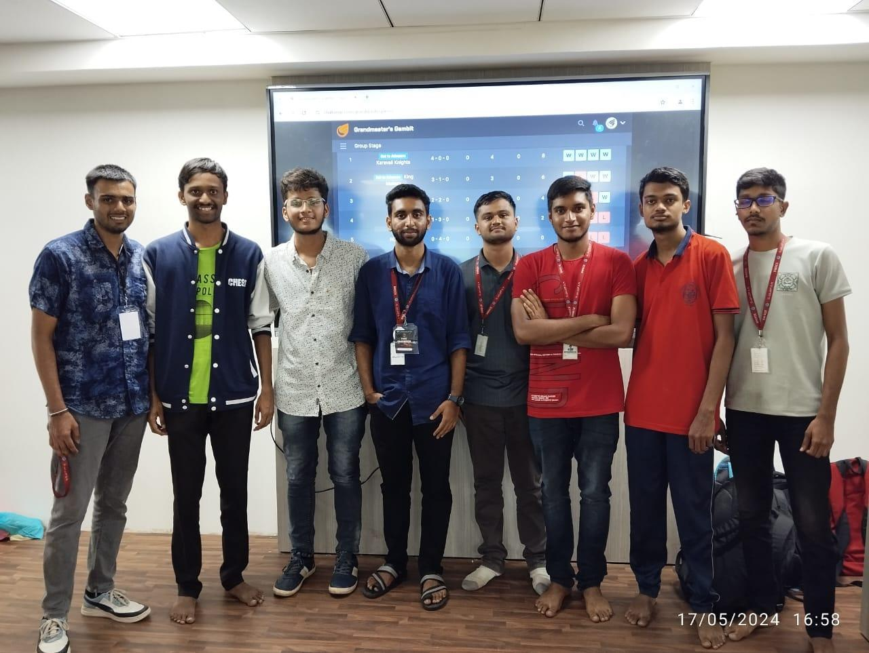
Two or three relevant Photographs of the activity: (Geo-tagged photos are preferable)

